CBSE RESULT ANALYSIS CLASS X AND XII -2023

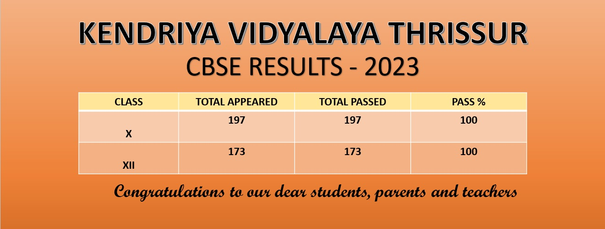

PERFORMANCE INDEX
CLASS X | 79.87
CLASS XII | 77.77

CLASS X TOPPERS
SLNO | ROLLNO | NAME | SECTION | TOT | PER
1 | 24144035 | VISHNUSREE,N, | 10C | 491 | 98.2
2 | 24144036 | GHANSHYAM,S, | 10C | 490 | 98
3 | 24144060 | BHAVYASHREE,T,PRAVEEN, | 10D | 490 | 98
4 | 24143893 | AADISANKAR,P,GIRIDAS, | 10A | 487 | 97.4
5 | 24143900 | ANAGHA,ROSE, | 10A | 485 | 97
6 | 24144024 | JOAN,LINTO, | 10C | 485 | 97
7 | 24143951 | ANGEL,MARIA,GEORGE, | 10B | 484 | 96.8
8 | 24144015 | AMEYA,N,K, | 10C | 484 | 96.8
9 | 24143992 | AMBIKA,S,NAIR, | 10C | 481 | 96.2
10 | 24143933 | PARVATHY,KRISHNA,E, | 10A | 479 | 95.8
11 | 24143917 | DHRISYA,RAMDAS, | 10A | 476 | 95.2
12 | 24143928 | MERIN,BIJU,K, | 10A | 475 | 95
13 | 24144078 | PRARTHANA,K,P, | 10D | 474 | 94.8
14 | 24143983 | SANJAY,V,S, | 10B | 471 | 94.2
15 | 24143904 | ANU,THARA,KRISHNA,C,A, | 10A | 469 | 93.8
16 | 24144032 | SIVANI,MENON, | 10C | 468 | 93.6
17 | 24143937 | VAISHNAVI,P, | 10A | 467 | 93.4
18 | 24143919 | ELIZA,LENIN, | 10A | 466 | 93.2
19 | 24143949 | ALAKANANDA,P,MENON, | 10B | 466 | 93.2
20 | 24143977 | PRIYAMVADA,T,P, | 10B | 466 | 93.2
21 | 24144063 | GAURI,LAKSHMI,K,MADHAVAN, | 10D | 466 | 93.2
22 | 24144012 | ABHAY,TONY, | 10C | 464 | 92.8
23 | 24143911 | AVENI,DEEPAK, | 10A | 463 | 92.6
24 | 24143942 | ABHISHEK,S, | 10B | 463 | 92.6
25 | 24144009 | SREERAG,P,N, | 10C | 461 | 92.2
26 | 24144079 | RAGHURAM,K,L, | 10D | 461 | 92.2
27 | 24143916 | CHETHANA,M,S, | 10A | 460 | 92
28 | 24143970 | JIYA,K,J, | 10B | 460 | 92
29 | 24143927 | LAKSHMI,NANDA,K,S, | 10A | 458 | 91.6
30 | 24144002 | HARIPRIYA,G, | 10C | 458 | 91.6
31 | 24144014 | AMAN,ANUPAM, | 10C | 458 | 91.6
32 | 24143962 | DACE,SEBI, | 10B | 457 | 91.4
33 | 24144010 | SRUTHI,PARVATHI, | 10C | 456 | 91.2
34 | 24144018 | DEVANANDHA,C, | 10C | 455 | 91
35 | 24143907 | ARDRASANKAR,T,PRAVEEN, | 10A | 453 | 90.6
36 | 24144055 | ANCIYA, | 10D | 452 | 90.4
37 | 24144066 | ISHAAN,ANIL,KARUMATHIL, | 10D | 451 | 90.2
38 | 24143939 | HENIN,TERESA,T, | 10A | 450 | 90
39 | 24144027 | KRISHNA,RAJ,V,J, | 10C | 450 | 90

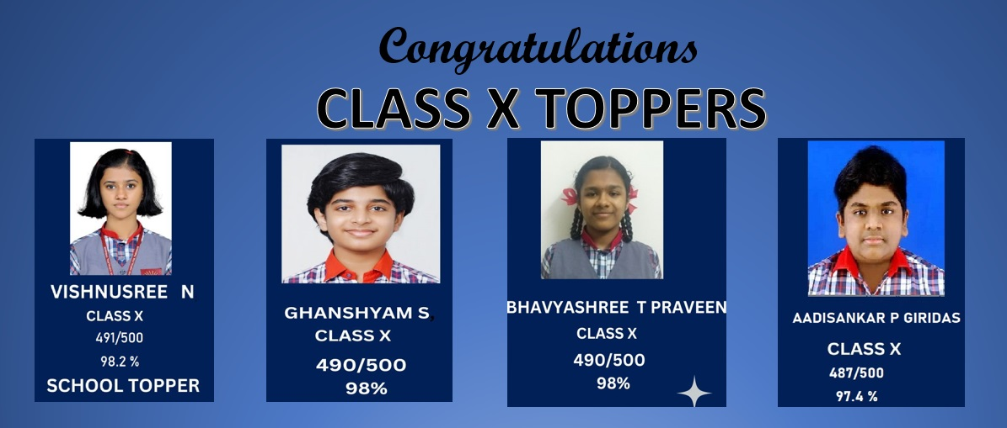

STUDENTS WITH ALL A1 IN CLASS X
SLNO | ROLLNO | NAME
1 | 24143893 | AADISANKAR,P,GIRIDAS,
2 | 24143900 | ANAGHA,ROSE,
3 | 24143911 | AVENI,DEEPAK,
4 | 24143933 | PARVATHY,KRISHNA,E,
5 | 24143951 | ANGEL,MARIA,GEORGE,
6 | 24143970 | JIYA,K,J,
7 | 24143992 | AMBIKA,S,NAIR,
8 | 24144015 | AMEYA,N,K,
9 | 24144018 | DEVANANDHA,C,
10 | 24144035 | VISHNUSREE,N,
11 | 24144036 | GHANSHYAM,S,
12 | 24144060 | BHAVYASHREE,T,PRAVEEN,

CLASS XII TOPPERS
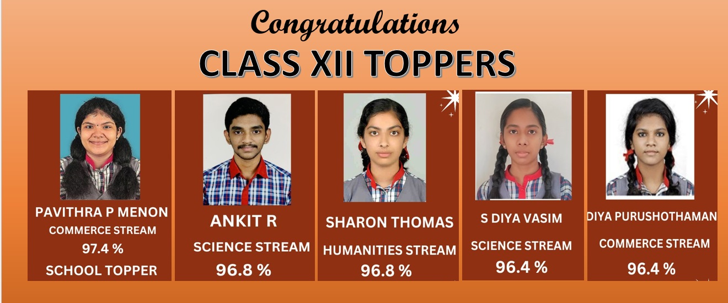
SCIENCE STREAM
SNO | ROLLNO | NAME | PER
1 | 24630781 | ANKIT R | 96.8
2 | 24630732 | S DIYA VASIM | 96.4
3 | 24630784 | ARJUN A | 96.2
4 | 24630726 | MEERA P | 96
5 | 24630727 | NANDITHA V | 96
6 | 24630703 | POURNAMI R MELETHIL | 95.6
7 | 24630808 | SWATHI JAYADEVAN | 95.6
8 | 24630775 | ADELYNE MISHA MITESH | 95.4
9 | 24630797 | K R GOURI BHAMA | 95.2
10 | 24630767 | SWATI SUKUMARAN | 95
11 | 24630806 | SOORAJ K R | 94.8
12 | 24630737 | NAVNEETH K J | 94.6
13 | 24630805 | SHREYA JAYACHANDRAN | 94.6
14 | 24630789 | DEVIKA P | 94.2
15 | 24630777 | AKSHAJ J | 93.8
16 | 24630788 | C V VARADA | 92.8
17 | 24630762 | LAKSHMI C R | 92.6
18 | 24630780 | ANJALI E V B | 92.6
19 | 24630720 | AUXLIYA MARIYA | 92.2
20 | 24630749 | ANITTA MARIA ALAPPAT | 92.2
21 | 24630809 | VISHNUPRIYA R | 92
22 | 24630702 | DEVIKA S WARRIER | 91
23 | 24630773 | ABHIRAM K J | 89.8
24 | 24630764 | RAHULDEV P | 89.4
25 | 24630763 | MALAVIKA M MANOJ | 89.2
26 | 24630769 | VAISHNAVI T | 89.2
27 | 24630774 | ABHIRAM V | 89.2
COMMERCE STREAM

SNO | ROLLNO | NAME | PER
1 | 24630842 | PAVITHRA P MENON | 97.4
2 | 24630820 | DIYA PURUSHOTHAMAN | 96.4
3 | 24630814 | ANUSREE A S | 96.2
4 | 24630822 | JACQUALIN JACOB | 96.2
5 | 24630843 | SANJANA V A | 94.4
6 | 24630836 | ADITI MENON | 93.4
7 | 24630815 | ANUSHKA S MENON | 93.2
8 | 24630811 | ALBERT DAVID | 91.6
9 | 24630837 | AEVLIYA ROSE | 91.4
10 | 24630823 | KARTHIK SYAM | 90.8
11 | 24630828 | AMRITA P S | 89.6

HUMANITIES STREAM

SNO | ROLLNO | NAME | PER
1 | 24630859 | SHARON THOMAS | 96.8
2 | 24630861 | ANJANA E R | 94.2
3 | 24630852 | AYISHA BINTH MANOJ | 94
4 | 24630869 | IRENE MARIA | 94
5 | 24630867 | EDWIN C XAVIER | 93.2
6 | 24630863 | ATHIRA A | 90.4

